**Artificial Intelligence and Expert System**

**Mid Semester Assignment**

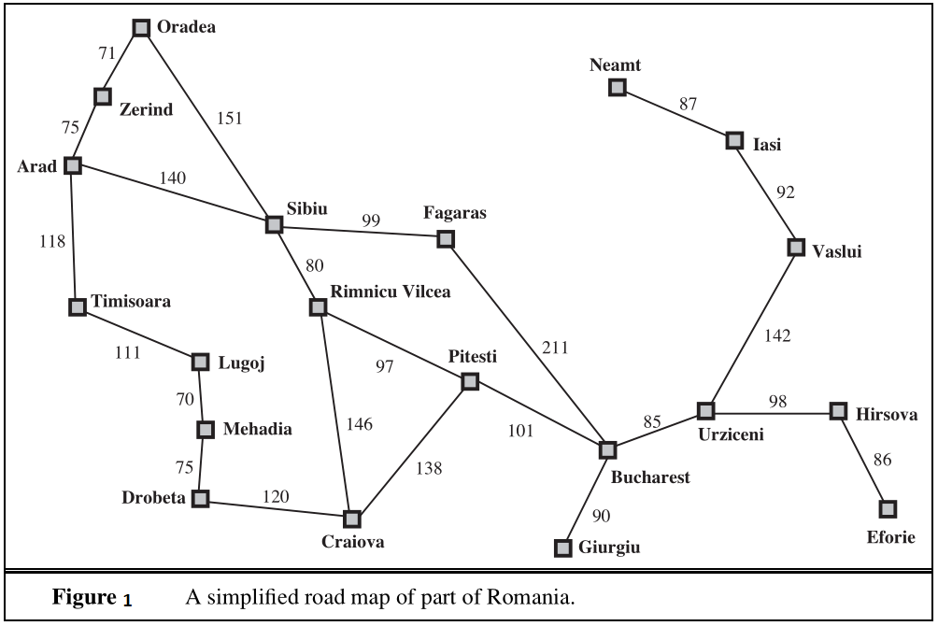

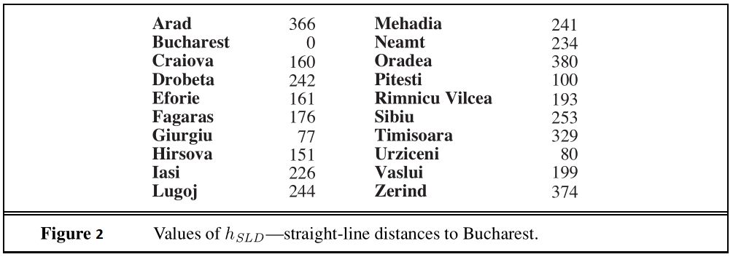

**Question:**

Find a path from ***Zerind*** to ***Bucharest*** using the four different algorithms described below:

1. Breadth First Search
2. Uniform Cost Search.
3. Greedy Best First Search
4. A* Search
5. Compare the result of these four algorithms in perspective of **time** and **optimality**.

**Instruction:**

1. You have to answer in the space given below.
2. Write your name and id in the given space below.
3. Save this file to pdf and upload in your portal account.
4. Submission deadline: 21/11/20

|  |  |  |
| --- | --- | --- |
| **Name: Zawed Quazi Akib** | **ID: 17-35455-3** | **Section: E** |

**Answer 1: Breadth First Search**

|  |  |  |  |
| --- | --- | --- | --- |
| **Step** | **Frontier** | **Explored Set** | **Expand** |
| 1 | Zerind |  | Zerind |
| 2 | Oradea,Arad | Zerind | Oradea |
| 3 | Arad,Sibiu | Zerind, Oradea | Arad |
| 4 | Sibiu,Timisoara | Zerind,Oradea,Arad | Sibiu |
| 5 | Timisoara,Rimnicu Vilcea,Fagaras | Zerind,Oradea,Arad,Sibiu | Timisoara |
| 6 | Rimnicu Vilcea,Fagaras,Lugoj | Zerind,Oradea,Arad,Sibiu,Timisoara | Rimnicu Vilcea |
| 7 | Fagaras,Lugoj,Pitesti,Craiova | Zerind,Oradea,Arad,Sibiu,Timisoara, Rimnicu Vilcea | Fagaras |
| 8 | Lugoj,Pitesti,Craiova,Bucharest | Zerind,Oradea,Arad,Sibiu,Timisoara, Rimnicu Vilcea,Fagaras | Lugoj |
| 9 | Pitesti,Craiova,Bucharest,Mehadia | Zerind,Oradea,Arad,Sibiu,Timisoara, Rimnicu Vilcea,Fagaras, Lugoj | Pitesti |
| 10 | Craiova,Bucharest,Mehadia | Zerind,Oradea,Arad,Sibiu,Timisoara, Rimnicu Vilcea,Fagaras, Lugoj, Pitesti | Craiova |
| 11 | Bucharest,Mehadia | Zerind,Oradea,Arad,Sibiu,Timisoara, Rimnicu Vilcea,Fagaras, Lugoj, Pitesti, Craiova | Bucharest |
| 12 | Mehadia | Zerind,Oradea,Arad,Sibiu,Timisoara, Rimnicu Vilcea,Fagaras, Lugoj, Pitesti, Craiova, Bucharest |  |
| 13 |  |  |  |
| 14 |  |  |  |
| 15 |  |  |  |

**Answer 2: Uniform-Cost Search**

|  |  |  |  |
| --- | --- | --- | --- |
| **Step** | **Frontier** | **Explored Set** | **Expand** |
| 1 | Zerin |  | Zerind |
| 2 | Arad,Oradea | Zerin | Oradea |
| 3 | Arad,Sibiu | Zerin,Oradea | Arad |
| 4 | Sibiu,Timisoara | Zerin,Oradea,Arad | Timisoara |
| 5 | Sibiu,Lugoj | Zerin,Oradea,Arad, Timisoara | Sibiu |
| 6 | Lugoj, Rimnicu Vilcea, Fagaras | Zerin,Oradea,Arad, Timisoara,Sibiu | Rimnicu Vilcea |
| 7 | Lugoj, Fagaras, Pitesti, Craiova | Zerin,Oradea,Arad, Timisoara,Sibiu, Rimnicu Vilcea | Lugoj |
| 8 | Fagaras, Pitesti, Craiova | Zerin,Oradea,Arad, Timisoara,Sibiu, Rimnicu Vilcea, Lugoj | Fagaras |
| 9 | Craiova,Bucharest | Zerin,Oradea,Arad, Timisoara,Sibiu, Rimnicu Vilcea, Lugoj, Fagaras | Pitesti |
| 10 | Craiova,Bucharest | Zerin,Oradea,Arad, Timisoara,Sibiu, Rimnicu Vilcea, Lugoj, Fagaras, Pitesti | Bucharest |
| 11 | Craiova | Zerin,Oradea,Arad, Timisoara,Sibiu, Rimnicu Vilcea, Lugoj, Fagaras, Pitesti, Bucharest. |  |
| 12 |  |  |  |
| 13 |  |  |  |
| 14 |  |  |  |
| 15 |  |  |  |

**Answer 3: Greedy Best First Search**

|  |  |  |  |
| --- | --- | --- | --- |
| **Step** | **Frontier** | **Explored Set** | **Expand** |
| 1 | Zerind |  | Zerind |
| 2 | Arad,Oradia | Zerind | Arad |
| 3 | Oradia,Sibiu,Timisoara | Zerind ,Arad | Sibiu |
| 4 | Oradia, ,Timisoara, Rimnicu Vilcea, Fagaras | Zerind ,Arad ,Sibiu, | Fagarus |
| 5 | Oradia, ,Timisoara, Rimnicu Vilcea, Bucharest | Zerind ,Arad ,Sibiu, Fagaras | Bucharest |
| 6 | Oradia, ,Timisoara, Rimnicu Vilcea | Zerind ,Arad ,Sibiu, Fagaras ,Bucharest |  |
| 7 |  |  |  |
| 8 |  |  |  |
| 9 |  |  |  |
| 10 |  |  |  |
| 11 |  |  |  |
| 12 |  |  |  |
| 13 |  |  |  |
| 14 |  |  |  |
| 15 |  |  |  |

**Answer 4: A* Search**

|  |  |  |  |
| --- | --- | --- | --- |
| **Step** | **Frontier** | **Explored Set** | **Expand** |
| 1 | Zerind |  | Zerind |
| 2 | Arad,Oradia | Zerind | Arad |
| 3 | Oradia,Sibiu,Timisoara | Zerind,Arad | Oradia |
| 4 | Sibiu,Timisoara, | Zerind,Arad,Oradia | Sibiu |
| 5 | Timisoara, Rimnicu Vilcea, Fagaras | Zerind,Arad,Oradia ,Sibiu | Rimnicu Vilcea |
| 6 | Timisoara, Fagaras,Pitesti,Craiova | Zerind,Arad,Oradia ,Sibiu, Rimnicu Vilcea | Fagaras |
| 7 | Timisoara, Pitesti, Craiova, Bucharest | Zerind,Arad,Oradia ,Sibiu, Rimnicu Vilcea, Fagaras | Bucharest |
| 8 | Timisoara, Pitesti, Craiova | Zerind,Arad,Oradia ,Sibiu, Rimnicu Vilcea, Fagaras, Bucharest |  |
| 9 |  |  |  |
| 10 |  |  |  |
| 11 |  |  |  |
| 12 |  |  |  |
| 13 |  |  |  |
| 14 |  |  |  |
| 15 |  |  |  |

**Answer 5: Compare the result of these four algorithms in perspective of time and optimality.**

|  |
| --- |
| **In term of time:**  **Greedy Best First Search faster than A* and A* is faster than Uniform Cost Search and Uniform Cost Search Breadth First Search.**  **In termal of optimality:**  **In term of Optimality**  **Uniform cost and A* Search are more optimal than Greedy and BFS**  **Conclusion since the costs are given and A* is both fast and optimal.. A* is the better search algorithm compare to the other three given algorithms.** |